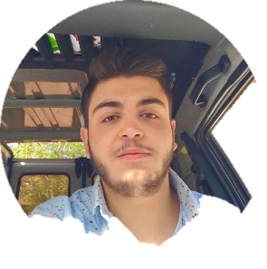

**Professional experiences**

* **Web developer 2021 (Freelancer)**
* **Special Lecturer**  **2018 – 2020**

**Strengthening in all scientific subjects (chemistry, mathematics, physics, life sciences)**

**education**

* **Web Development Certificate:** [**https://academy.hsoub.com/certificate/N1JY264O93CCNVVUUF6L.pdf**](https://academy.hsoub.com/certificate/N1JY264O93CCNVVUUF6L.pdf)

**Hassoub Company-2021**

* **Baccalaureate in general Science 2018-2019**  **-**  **Rahbe High School**

**Rahbe, Akkar – Lebanon**

**Languages**

1. **Arabic**
2. **English**
3. **French**

**Skills**

* **Computer skills:**

1. **Microsoft office ( word, powerpoint, excel…)**
2. **VsCode**
3. **Internet (Navigation and Research)**
4. **Git**

* **Programming skills:**

1. **java (oop, data structures and algorithms)**
2. **R programing (R data analysis)**
3. **DataBase (Sql)**
4. **Web Development :**
5. **Html**
6. **Css**
7. **,JavaScript and Jquery**
8. **Bootstrap**
9. **Npm Webpack**
10. **Sass**

**Workshops and training**

* **Workshops to prepare mentors with Professor George Rizk to deal with young people**
* **Volunteer:**

**•Orthodox Youth Movement - Mentor for a group (3-14 years)**

**• All municipal activities**

**• Assistant in an association to help stray and lost animals**

+961 81252142

[doryy.nehme@gmail.com](mailto:doryy.nehme@gmail.com)

19 years old

Lebanese

**Dory Nehme**